|  |  |  |  |  |  |
| --- | --- | --- | --- | --- | --- |
| Description: Description: S:\AdminShared\All Staff\1 College Logo's\Baldivis_Logo_colour.jpgName: | \_\_\_\_\_\_\_\_\_\_\_\_\_\_\_\_\_\_\_\_\_\_\_\_\_\_\_\_\_\_\_\_\_\_\_\_\_\_\_\_\_\_\_\_\_\_\_\_\_\_\_ | | | | Date: *\_\_\_\_\_\_\_\_\_\_\_* |
|  | **Year 11 Applications**  **Test 4, 2016**  **Topics – Scales, Similarity and Matrixes Arithmetic** | | | | 46  = % |
| **Total Time:** | ***45*** *minutes* | |  | | |
| **Total Reading:** | *5**minutes* | |
| **Total Working:** | *40**minutes* | |
| **Weighting:** | *7% of the year,14% of the Semester.* | |
| **Equipment:** | *SCSA Formula Sheet; 1 page notes (A4 one side,* ***Unfolded****), CASIO ClassPad; Scientific Calculator, ruler* | | | | |
| **SECTION 1: CALCULATOR FREE** | | | | | |
| **Time:** | ***15*** *minutes* | **Marks for Section 1:** | | *15* | |
| **Reading:** | *2**minutes* | **Equipment Allowed:** | | *Nil* | |
| **Working:** | *13**minutes* |  | |  | |

|  |  |
| --- | --- |
| **1.** | **[1 mark]** |

Circle the correct answer.

*ABC* and its image under (an enlargement) are shown. What is the enlargement factor?

**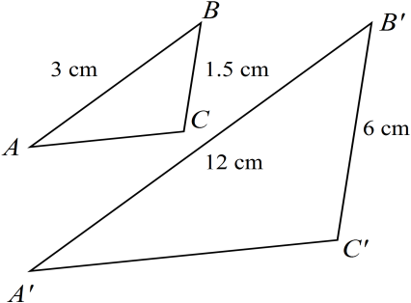**

NOT TO

SCALE

|  |  |
| --- | --- |
|  | **a) 2 b) 4 c) 3 d) 6** |
|  |

**2. [2 marks]**

Rebecca prints out a square photograph and then decides that she likes it so much she wants to frame it. She needs to enlarge the photo to four times the original size. If the area of the original photograph was 100 cm2, what is the area of the enlarged photograph?

**Area of enlargement = 100 x 42 = 1600 cm2**

**3. [4 marks: 1 mark each]**

Use Matrix A below to answer the following question;

Matrix A = 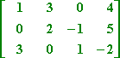

1. How many elements are there in Matrix A?

12

1. What is the order of Matrix A?

3 x 4

1. Is Matrix A a square matrix?

No

1. What is the value of element a13 ?

0

**4. [4 marks]**

Members of one family, Gino, Cara, Nick and Tina, live in four different places and they communicate regularly. They all use the same internet texting app as well as email to send messages to each other. Skype is used by Cara, Nick and Tina but only to talk with Gino who is overseas. Both landline and mobile text are used by Cara, Tina and Nick to communicate locally. Facebook is used by Gino, Cara and Nick to communicate internationally.

With each row representing a different person, create a labelled matrix to represent the **number of ways** each person communicates with each of the others.

Assume no-one communicates with themselves.

1 mark per row, -1/2 mark each error up to 1 mark per row.

**5. [4 marks; 1, 1, 2]**

Answer the following given that:

1. A + B =
2. 2B =
3. AB =

**~ END OF TEST SECTION 1 ~**

|  |  |  |  |  |
| --- | --- | --- | --- | --- |
| Name: | \_\_\_\_\_\_\_\_\_\_\_\_\_\_\_\_\_\_\_\_\_\_\_\_\_\_\_\_\_\_\_\_\_\_\_\_\_\_\_\_\_\_\_\_\_\_\_\_\_\_\_ | | | Date: *\_\_\_\_\_\_\_\_\_\_\_* |
| **SECTION 2: CALCULATOR ASSUMED** | | | | |
| **Time:** | ***30*** *minutes* | **Marks for Section 2:** | *31* | |
| **Reading:** | *3 minutes* | **Equipment Allowed:** | *1 page notes (A4 one side),*  *CAS calculator, ClassPad, ruler* | |
| **Working:** | *27**minutes* |  |  | |

**6. [8 marks: 2, 2, 2, 2]**

Use the matrices below to answer the following matrix calculations if they are possible;

A = B = C = D =

1. AD

Impossible as the number of columns of A is different to the number of rows of D

1. 2B2

2 x B x B =

2 x =

1. 4A + B

4 x + =

1. 2CD

2 x x =

**7. [2 marks]**

Two rectangles are similar. The smaller rectangle has sides 12 cm and 7 cm. The longer side of the larger rectangle is 30 cm. How long is its shorter side? (Hint: Draw a diagram)

12cm 30cm

7cm xcm SF = = 2.5 🗸

x = 2.5 x 7 = 17.5 🗸

**8. [2marks]**

The plan of a building is drawn to a ratio of 1:20. If the width of the building on the plan is 205 cm, what is the width of the actual building?

1:20 actual size = 20 x 205cm = 4100cm **or** 41m

**9. [4 marks: 1, 1, 2]**

Use the Diagrams below to answer the following questions.

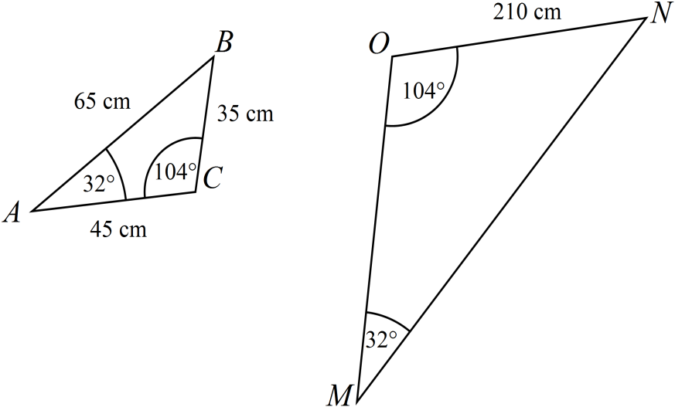

1. What similarity rule can be used to prove  is similar to?

AAA

1. What scale factor was used to draw?

6

1. Given this scale factor, what are the lengths of the remaining two sides of ?

65 x 6 = 390 🗸 , 45 x 6 = 270 🗸

**10. [5 marks: 2, 1, 1, 1 ]**

The following table shows the number of first, second and third places that five competing

athletes gained, at a recent athletics carnival.

|  |  |  |  |
| --- | --- | --- | --- |
|  | 1st | 2nd | 3rd |
| Zane | 2 | 1 | 3 |
| Michael | 1 | 0 | 4 |
| Daniel | 0 | 5 | 2 |
| Matthew | 2 | 2 | 2 |
| Benjamin | 3 | 0 | 4 |

1. Construct a 5 x 3 matrix to represent these results and call it Matrix A.

Matrix A = 🗸🗸

1. If athletes were awarded 5 points for 1st place, 3 points for a 2nd place and 1 point for a 3rd place construct a 3 element column matrix and call it Matrix B.

Matrix B = 🗸

1. Using the matrices A and B calculate the total points received by each athlete.

x = 🗸

1. An award is given to the athlete who earns the most points during the meet. Who of the 5 athletes won the award?

Benjamin 🗸

**11. [4 marks: 2, 2]**

Use the following floor plan to answer the questions below given that it has been drawn to the following scale 1: 1.5.

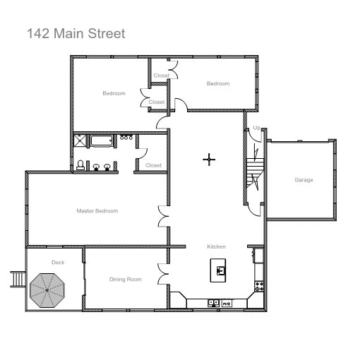

1. What are the dimensions of the garage in real life?

(3cm – 3.2cm) x (3.4cm – 3.6cm) = (4.5m – 4.8m) x (5.1m – 5.4m)

1. What would be the area of the deck in real life?

Area = Length x width measured then changed into m2 using the scale 12:1.52

Note: they can convert the measurements first using the scale 1:1.5 or at the end using 1unit2: 1.52 I gave 2mm either side of my measurements for accuracy as some students used the inside of the room for dimensions.

**12. [6 marks: 4, 2]**

A child is playing in a sand pit and is using a small cube that is filled to the top with sand, to fill a similar larger cube. Given that the smaller cube has a side length of 10cm and the scale factor is 5:

1. How many times will he have to fill up the smaller cube in order to fill the larger cube with sand? (Hint: all regular solids are similar)

10cm

55cm

Volume 1 = S3 Volume 2 = S3

= 10 x 10 x 10 = 55 x 55 x 55

= 1000 cm3  🗸 = 166375 cm3 🗸

Volume 2 / Volume 1 = 166375 / 1000

= 166.375 🗸

Therefore 167 times 🗸

1. If the child now decides to fill the cubes with water, using the same process, will this change the number of times he has to fill the smaller cube? (explain your answer)

No 🗸

Something along the lines of: the relationship between the volume and capacity of the two cubes does not change, as they are similar 3D shapes being regular. All cubes are regular. 🗸

**~ END OF TEST SECTION 2 ~**